ICSA Competition Committee Report for Annual Meeting 2026

The ICSA Competition Committee met bi-weekly for the duration of 2025 and 2026. We have
worked hard with the Spring Championship hosts and ICSA President Greg Wilkinson to
approve officials, set fields of play, and create/edit race documents. The CC also ran team
race and fleet race selection with the essential help of Hannah Lynn. Isaac Clark was
parliamentarian for the Women’s Committee and Claire Dennis for Open.

The CC spent a lot of time this year on re-grading the regattas of the ICSA Interconference Fall Schedule based on competitiveness. These grades will not become active until Fall of 2027. The CC also spent a large amount of time providing feedback to conferences regarding their now dead, split seasons proposals.

Competition Committee Members:
Isaac Clark (Chair)
Scott Corder
Claire Dennis
Connor Blouin
Charles Higgins
Scott Ikle
Allison Jolly
Bill Healy
Chris Klevan
John Mollicone
Craig Mueller

Report on 25-26 Championships:
Open and Women’s Singlehands: Hosted by Old Dominion University
Match Race: Hosted by University of South Florida and St. Petersburg YC.

Open and Women’s Team Race: Hosted by Tulane University with support from Southern YC and New Orleans Community Sailing
Open and Women’s Fleet Race: Hosted by the University of South Florida at Skybeach Resort.

Competition and Championship Committee Split:
Responsibilities: Both committees must approve recommended changes to the Championship Conditions.
- Competition Committee - responsible for the nature and quality of competition throughout the ICSA.
  - Selection Process
    - Selector Approval
    - Working with the technical advisor
    - Organizing and running the Selection Process, including providing parliamentarians and scheduling selection meetings
    - Evaluating and providing recommendations to the ICSA Board of the selection process
  - Regatta Grading and Membership Classifications
    - Evaluating and grading regattas
    - Evaluating and assigning team membership classifications
  - Creating the Conditions for quality competition in the ICSA
    - Evaluating, analyzing, and making recommendations to the national championship formats, schedules, and qualification process.
    - Evaluating, analyzing, and making recommendations to the ICSA regatta calendar
- Championship Committee - responsible for the planning, approvals, management, and execution of the National Championships.
  - Race Official Approval and record keeping of ICSA-approved officials.
  - Race Document editing, approval, and acting as stewards of the ICSA Race Doc templates.
  - Soliciting Bids, recommendations to the board, and communication with bidders to answer questions.
  - Management of national championships by working with hosts on all aspects of running the championships.
  - Working to create a formal signed Hosting Agreement/Rental Agreement that outlines responsibilities, costs, schedules, and spaces between the two parties.

Changes to the Championship Conditions:

10.3 The preferred format shall be three round robins, beginning with a round robin of all teams. This initial round will be seeded by the ICSA Team Race Selection Committee into equal groups of 6 for Women’s and 8 for Open. The Preliminary Round of all 12 for Women’s (16 teams for Open), followed by a round of the top 6 Women's (8 Open) teams from the Preliminary Round, followed by a round of the top 4 teams from both previous rounds based on cumulative scores.

Change: 10.3 The preferred format shall be three round robins, beginning with a round robin of all teams. This initial round will be seeded by the ICSA Team Race Selection Committee into equal groups of 6 for Women’s and 8 for Open. The Preliminary Round of all 12 for Women’s (16 teams for Open), followed by a round of the top 6 Women's (8 Open) teams from the Preliminary Round, followed by a round of the top 6 teams from both previous rounds based on cumulative scores.

Changes to the Procedural Rules:

18C
ii) Course Duration - The recommended race duration times are described below. Races shall be timed from the start of the race until the finish of the first boat in that race.
Dinghy fleet race 20 minutes
Team race 10 minutes
Match race 20 minutes (15 minutes in earlier rounds)
Fleet Racing in Boats > 19 feet long 40 minutes
Singlehanded 25 minutes

18C
ii) Course Duration - The recommended race duration times are described below. Races shall be timed from the start of the race until the finish of the first boat in that race.
Dinghy fleet race 20 minutes
Team race 8-10 minutes
Match race 20 minutes (15 minutes in earlier rounds)
Fleet Racing in Boats > 19 feet long 40 minutes
Singlehanded 25 minutes

Selection Process Changes:
Based on the recent decisions of the ICSA Executive Committee the Competition Committee will be altering some of the mechanics for selector management. It is worth noting that the CC is solely in charge of approving selectors (CC Ap.A 1.1). It is also worth noting per CC 3.2 the expansion of the Women’s Team Race field is temporary.

The selector application asks below and provides links the the ICSA Championship Conditions while also providing CC Ap.A 1.1-1.7 written out in the description.
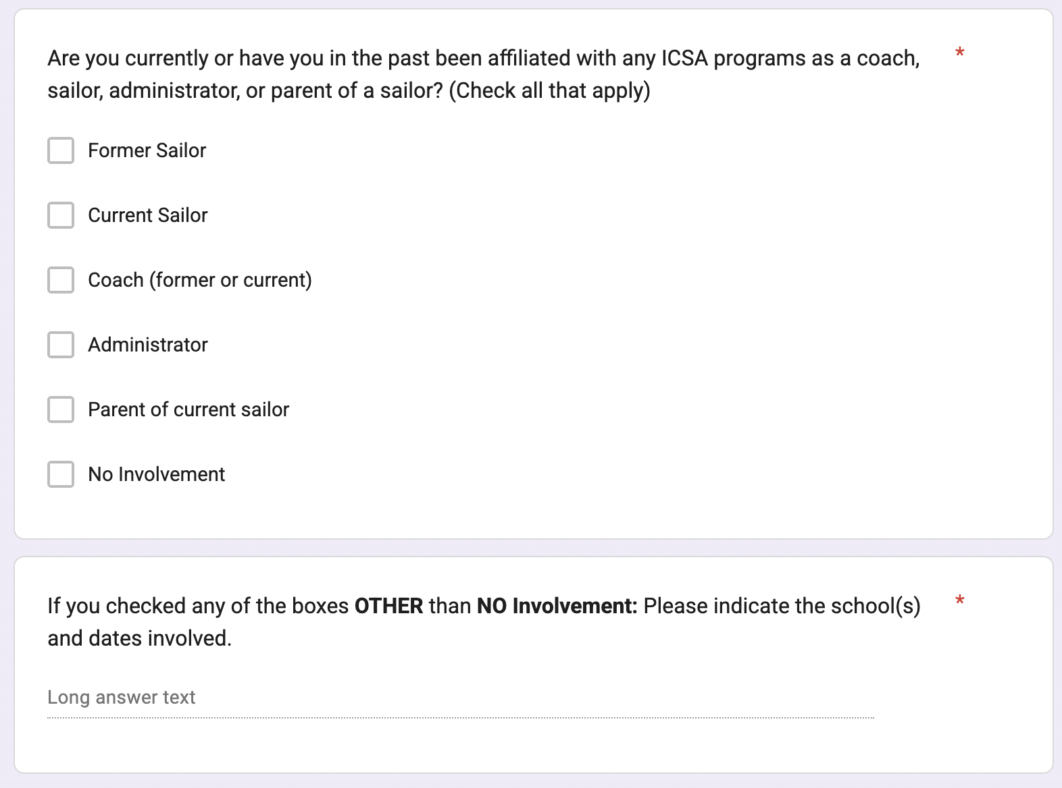

We will alter the above selector application question to match CC Ap.A 1.8.

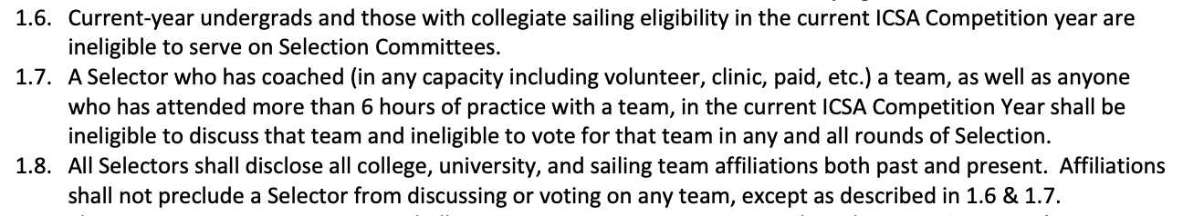

COMMON OPEN QUESTIONS:
- Should Weekend 11 be used to create a direct head to head for bubble teams?
  - MAISA CC 4-6, NEISA 5-8, SAISA 2-4?
- Should the ICSA Board task the Competition Committee to propose minor to significant cost-containment reforms to help reduce the cost-burden of competition?
- Should some conferences use Fall Fleet Race qualifiers as their direct qualifier into spring FR nationals to clean up spring scheduling conflicts?
- Should team racing be mixed gender (both genders represented in each role) to provide more accessibility to team racing for smaller teams and women’s sailors, further cost contain and condense the quality of competition?
  - The logic is smaller teams without 3 women’s skippers cannot compete in women’s team racing, and most spring women’s fleet race regattas have been taken off the schedule to make way for Women’s Team Racing.
- Is there enough quantity of data to support selection for Match Race and Singles? Should it be direct sail-in for our more niche disciplines?
- Should a “chair selector” deliver a report summarizing the process without mentioning any specific teams or conferences?

Bids (Tulane 2027 Singlehands, Vermont 2028 FR)

Please review via the link below.
PREFERENCE FOR DATES FOR 28 FR PENDING ON POLL

https://docs.google.com/spreadsheets/d/1edv2U-D6gZr5eS69kiUvImRZxWQTcbi3i9xXtds3JdY/edit?usp=sharing

