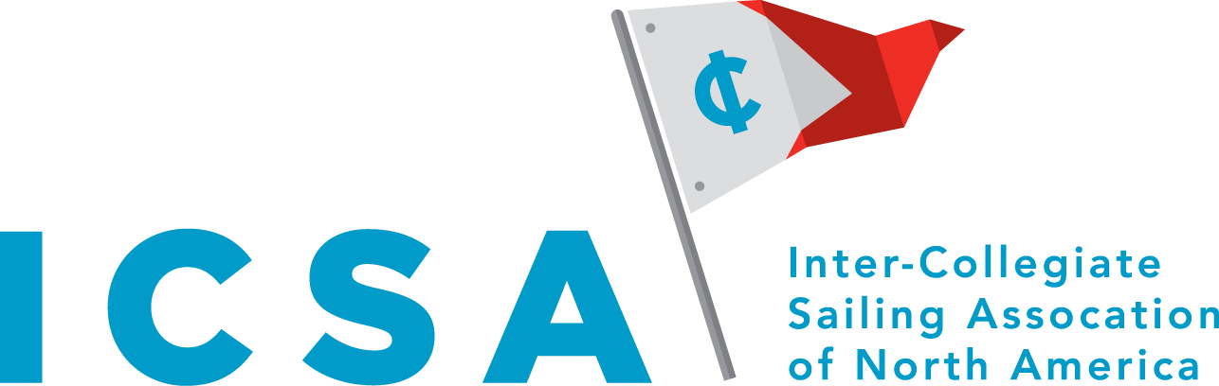
Inter-Collegiate Sailing Association of North America, Inc.
2026 Annual Meeting
14 May 2026, 1000 EST, SkyBeach Resort
In Person and Virtual Zoom Meeting

A G E N D A

Voting Spreadsheet

- Call to order (Alex)
- Roll call (Richards)
- Additions to the agenda (Richards)
- Reading and approval of the minutes of the last meeting, May 18 2025 (Richards)
- President's Report (Wilkinson)
- Treasurer’s Report (Blagden)
  - Report on Budget
  - Fees and Dues for Spring 2027 Championships to cover costs
- Secretary’s Report (Richards)
  - Update on Annual Meetings posting on webpage
- Executive Director’s Report (Fanta)
  - Overview of Agenda
- Standing Committee Reports
  - All-Academic Sailing Team (Foster)
    - Update on 2026 Awards
  - All-America Selection Committee (Higgins)
    - Update on 2026 Awards
  - Communications and Website (Radtke)
    - Update on 2026 Communications
  - Competition Committee (Clark)
    - Report on 2026 Championships
    - Request to split Competition and Championship Committees (In New Business)
    - Team Racing National Championship Report (In New Business w/Scheduling Comm)
    - Championship Bids and Status and Dates Update
      - 2026 Match Race Nationals - USC/Balboa Yacht Club
      - 2026 Singlehanded Nationals – Fordham/American YC
      - 2027 Team Race Nationals - Navy
      - 2027 Fleet Race Nationals - Navy
      - 2027 Match Race Nationals -
      - 2027 Singlehanded Nationals – Tulane (Proposed)
      - 2028 Team Race Nationals - Chicago (Proposed, not confirmed)
      - 2028 Fleet Race Nationals - Vermont

  - Procedural Rules (Paiva) (see separate document)
    - SAISA proposal for rotational flexibility
    - Tie-breaks clarification
    - PR 25(a) regatta completion
    - College Roll clarification
    - ICSA Case Book
  - Scheduling Committee (Mcgranahan)
    - 2026-2027 Schedule
    - Codify National Invitational/Regional Teams Fleet Race Championships (with Championships Committee in New Business)
    - Add Scheduling Rules to PRs Addendum (in New Business) (see separate document)
  - Eligibility Committee
    - Committee Update
    - Add Recruiting Committee
    - Recruiting PRs updates

- Old Business
  - Ad-hoc committee to look at the geographic competitive imbalance and conference realignment.
  - Olympic Pathway Partnership
    - Singlehandeds update
  - Ability to Conduct Fleet and Team Race Championships to reduce Graduation conflicts and costs (Executive Director)
    - Split Seasons are not proposed
    - Options on scheduling for Spring Championships (see separate document)
      - Spring Team Racing scheduling options

- New Business
  - Bylaws update to clarify: (Exec Director)
    - Split Competition and Championship Committee (see separate document)
    - ICSA Membership Clarification: (see separate document-bylaws update)
      - Registered sailors are members of ICSA as part of a team
      - Teams with paid dues are members of ICSA
      - Conferences are members and administrative leads of teams in their respective geographical regions
      - Implications: ICSA is the governing body and the administrative lead for college sailing
      - Implications: ICSA provides at ICSA Organizing Authority (OA) events and other events under ICSA direction (Board meetings and similar):
        - General Liability Coverage for members at ICSA events
        - Borrowed Boat Insurance at ICSA events
          - Deductible is Team responsibility if damage occurs
        - D&O Insurance for specified Board Members and Officers
          - At National level: President, Secretary, Treasurer, Board Members, Executive Director, Standing Committee Chairs
          - At Conference level: Commissioner, Secretary, Treasurer
        - OA Activities and Approval Authority as well as other duties as laid out in the Bylaws and Procedural Rules

  - Dues to US Sailing
    - Renew Affiliated Organization Membership
    - Clarify membership benefits
  - TR Scheduling change to adapt to Selection (Competition and Scheduling Committee) (see separate document)
    - Spring Team Race Scheduling/Berth allocation for CR and R regattas to Organizing Authority
    - Spring Team Race Weekend 10/11 events berth allocation to aid Selection
    - Team Race Championships timing options
    - Expand Women’s Team Racing Nationals to 16 teams
    - Format options with 16 Teams
  - College Sailing Inter-Collegiate Offshore and Sloops (Executive Director) (see separate document)
    - Designate permanent IOR and Sloop Committee/Sub Committee (Stokes)
      - Procedural Rule Proposals
      - Act as OA for IOR and Sloops
      - Provide members for Standing Committees to include Scheduling, All-Academic, etc
    - Procedural Rule Appendix Proposal/Approval (Stokes)
    - Membership on Scheduling, Rules, Competition for designated issues
  - Codify National Invitational/Regional Teams Fleet Race Championships (with Championships Committee)
    - Separate Committee/Sub Committee establishment
    - Membership on Scheduling, Rules, Competition for designated issues
  - Codify Scheduling Rules within PRs (Follow up from Winter Meeting) (Thompson) (see separate document)
  - Statistical Models to improve Selection (Executive Director)

- Report of Nominating Committee
  - Vote on Slate of Proposed Officers and At-Large Board Members (see separate document)
  - Updated Boards and Committees Membership

- Schedule next meeting (Richards)

- Adjourn (Undergraduate VP)

Respectfully submitted,

