College Rankings Proposal

The Issue
The Sailing World Rankings suffer from three issues that undermine their credibility. When Sailing World opened the rankings to all college coaches instead of just three the thought was that more coaches would lead to a better ranking. Right from the start this proved to be an incorrect assumption when one team received 17 of 27 1st place votes but ended up ranked 3rd because some coaches didn’t include them in the rankings. Allowing any coach to vote leads to much inconsistency since some coaches vote one week and not the next and the coaches voting one week use different criteria than ones voting in another. The 2nd issue that we have is oversight. In the past when there were three rankers Ann Campbell would audit the rankings in case a team was forgotten or ranked higher or lower than their record would suggest. Ann would contact the coaches and ask if them to double check to make sure their ranking was accurate. This oversight is lacking in the new system so we are left with teams that don’t deserved to be ranked receiving votes. Three examples of this be seen from the November 16, 2017 rankings. Issue 1 is the Gannon University Women’s Team receiving a vote. Gannon doesn’t have a women’s team. This was probably due to an error on the drop down menu but it was published.
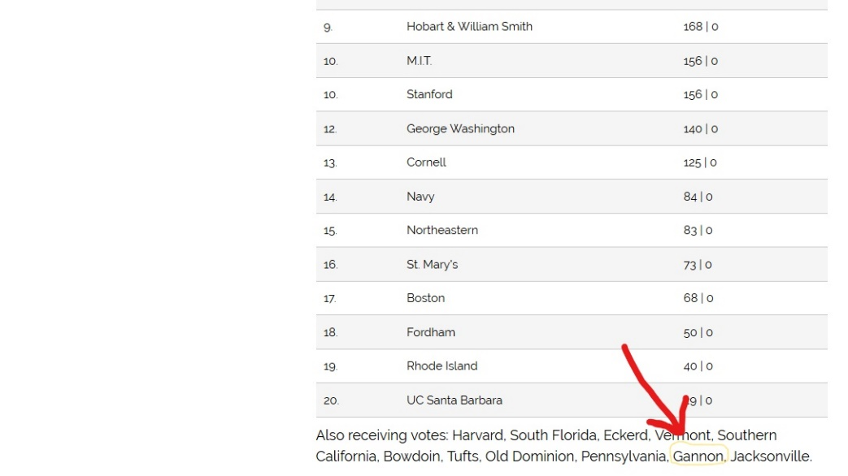
2. From the same ranking we also have the Georgetown Women’s Team receiving a number 1 vote even though they had not won a regatta all fall and were not deserving of a #1 vote.
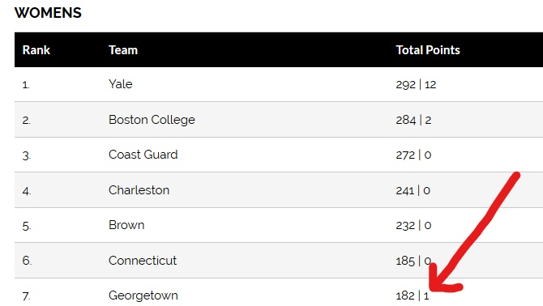

3. From the last Coed Ranking we have Marquette Receiving a Vote even though their record did not come close to deserving a national ranking.
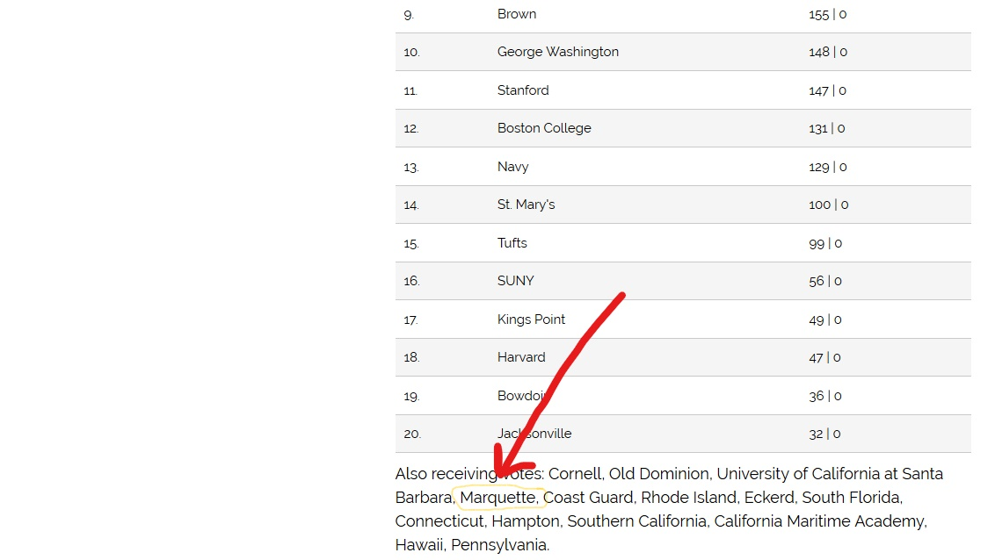

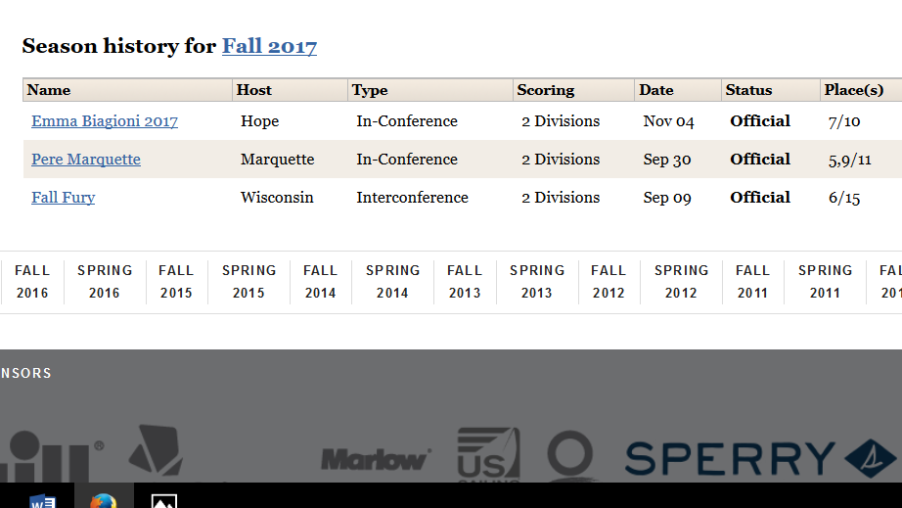

Our rankings are very important to many teams who work very hard to break into the top 20 and allowing teams to be ranked that clearly don’t warrant a ranking makes a mockery of our ranking and our sport.

The Solution
As an organization we need to do our part to make sure our rankings are as credible as possible. Understanding that no ranking will be perfect and coaches will always disagree to some degree with where their programs are ranked we can certainly do better.

Consistency
To combat the issue of consistency while also allowing more coaches to vote ICSA and Sailing World should use the following solution. For each semester the rankers should be the same for each ranking. Conferences should appoint the rankers. The number of rankers should be tied to the size of the conference and the fact that some conferences will have trouble finding people to be consistent rankers. Here is what the ranker make up should look like.
NEISA 4
MAISA 4
SAISA 2
MCSA 2
PCCSC 2
NWICSA 1
SEISA 1

Oversight
The rankings should be audited by conference Commissioners to make sure that they are as accurate as possible. Commissioners should be able to see the ranking to see if a team’s ranking is wildly off. If the commissioners see something that looks wrong, they will ask the ranker to double check to make sure what they submitted was accurate. Rankers will have the final say in rankings and commissioner should not be able to change a ranking. For Conference Rankings each Conference commissioner should audit their own ranking. National Rankings will be audited by Commissioners from MAISA, NEISA and any other Commissioner who wants to help.

Ranking Schedule
Since the Fall or 2018 features In conference competition first the rankings should be adjusted and Conference Rankings should be the only rankings in September. National Rankings can happen after the first weekend of Coed Showcase Regattas. Having a national ranking in September no longer makes since.

While ranking will never be perfect these changes will certainly make them better.

